Download the “5m Sales Records.csv” zip file under Week #1’s artifacts section. **Unzip** and **then store** the spreadsheet containing five million rows in your local hard drive.

Open a new worksheet



Data





Get Data

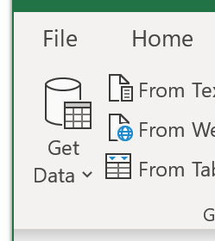



From File

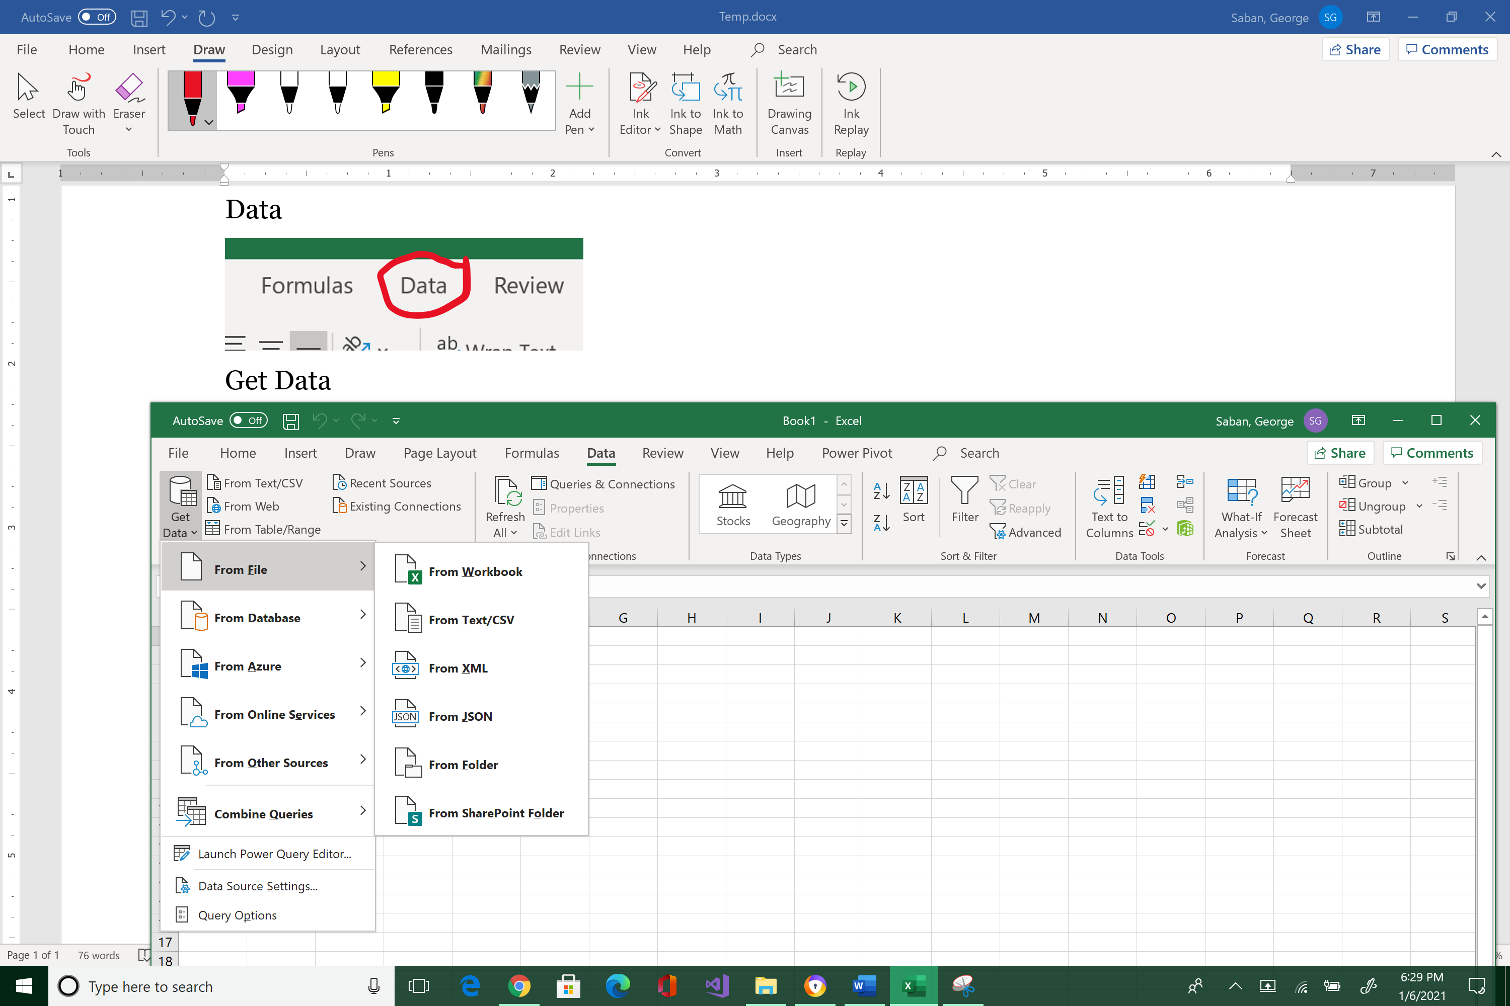



From Text/CSV

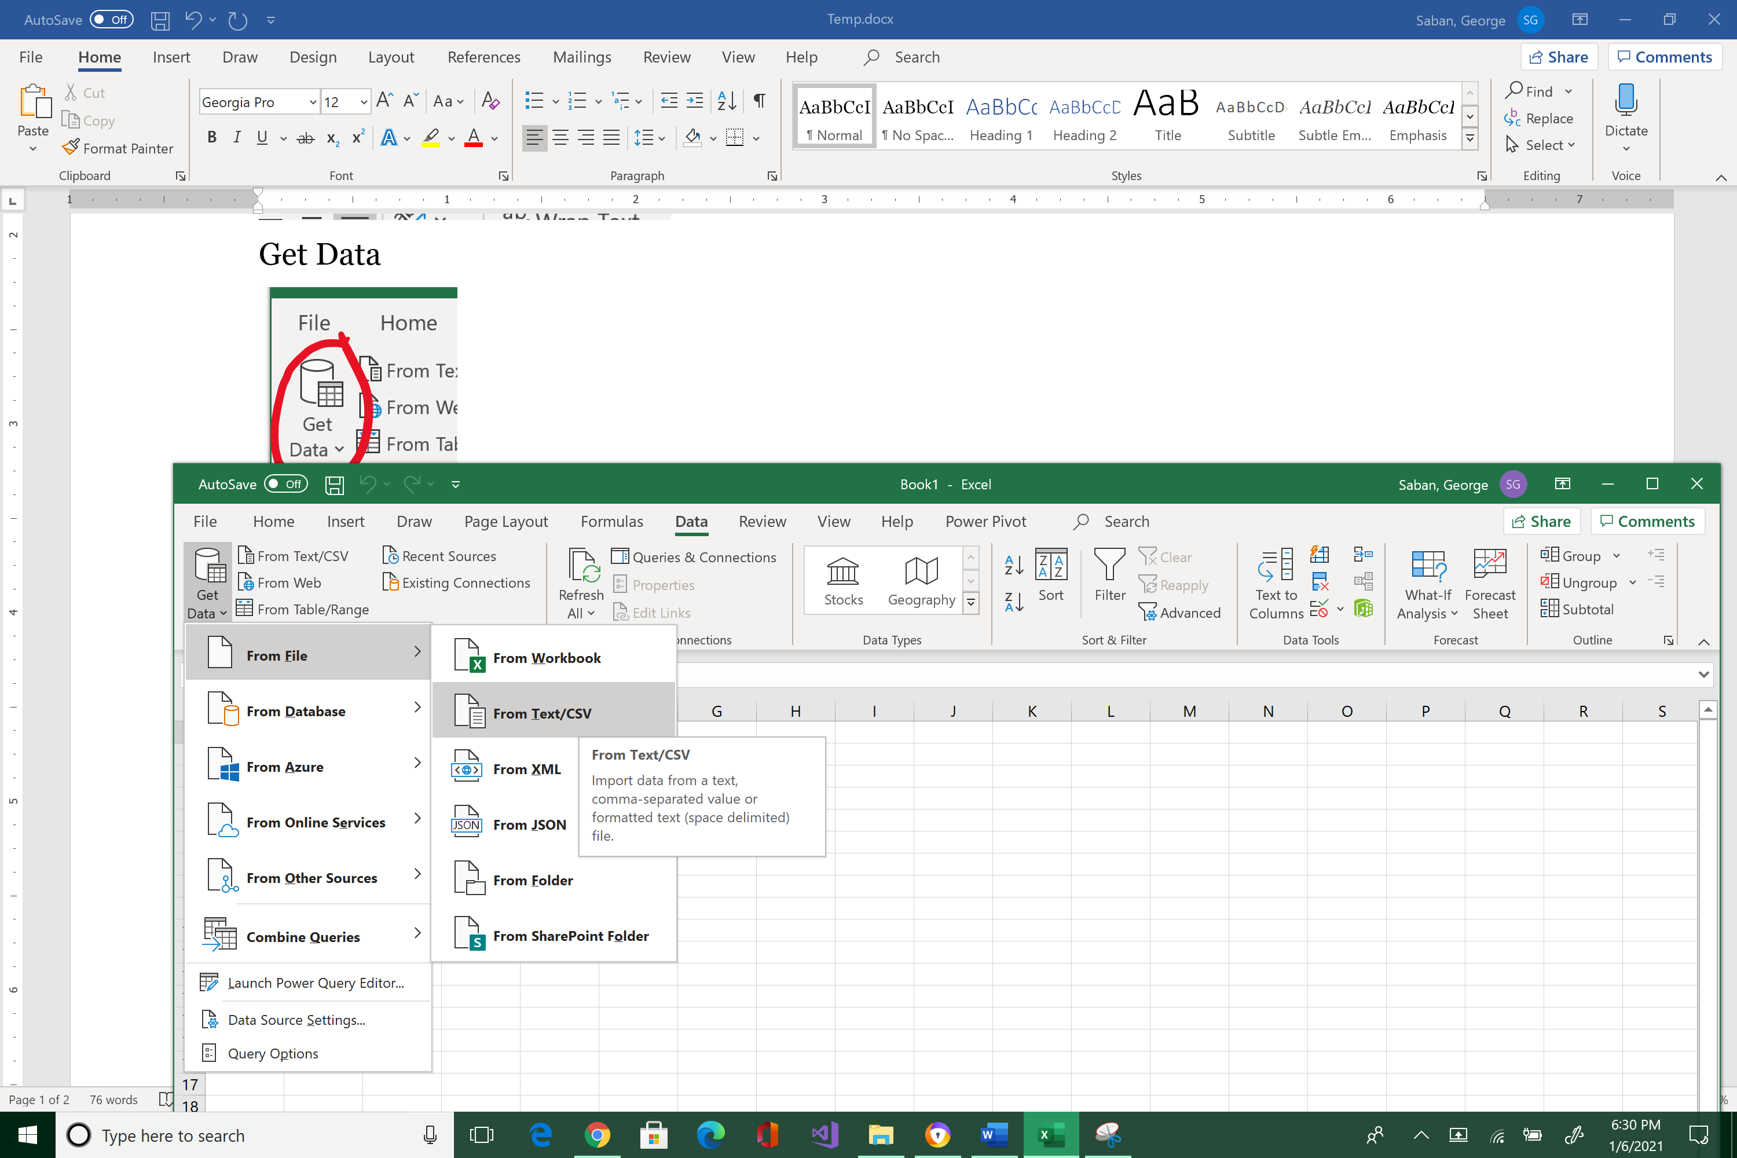



Drill down to “5m Sales Records.csv” file location and Import

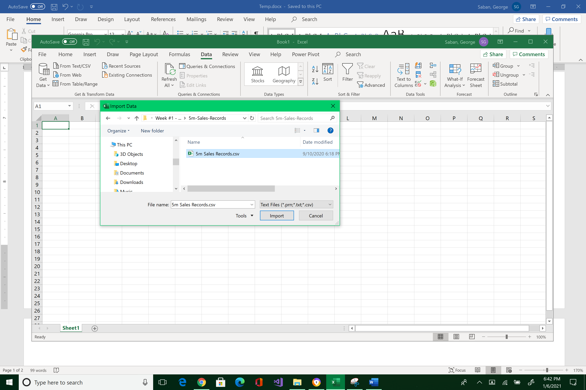



Load drop-down arrow (not Load)

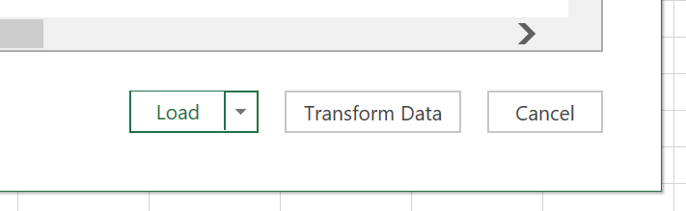



Load To…

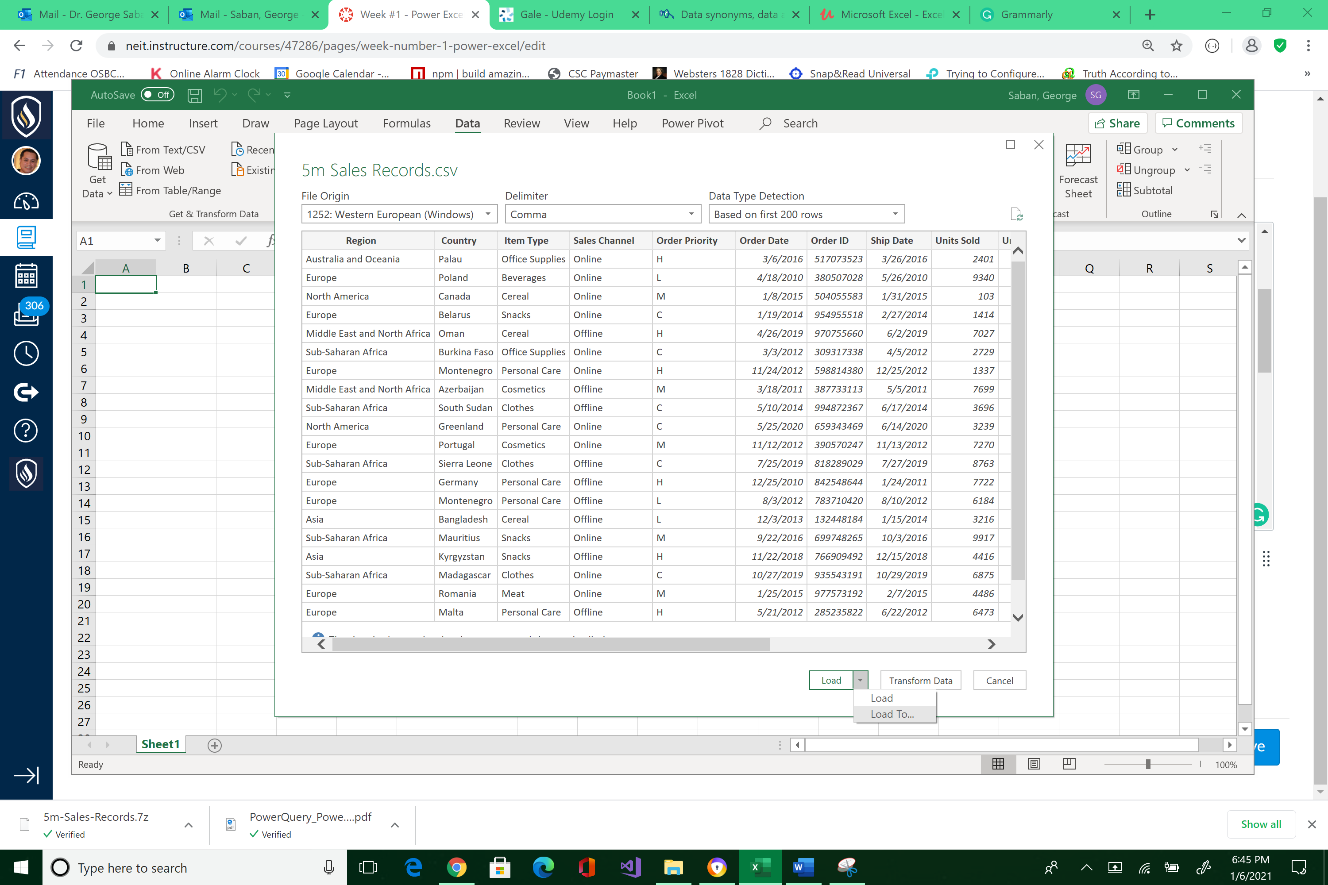



In the Import Data pop-up menu, select “Only Create Connection”, and “Add this data to the Data Model,” then click OK

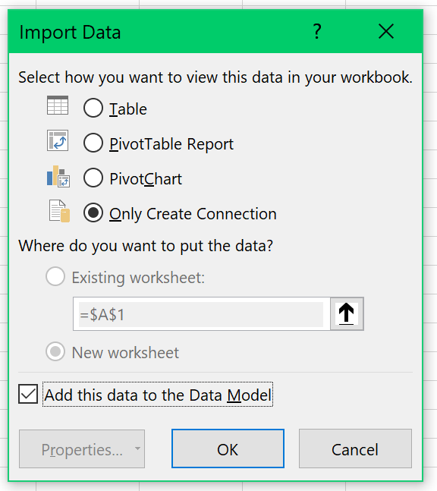



*Note the loading status on the right pane as it reads 5 million records . . .*

*Information goes straight to the Data Model which is a compression engine. The importing of multi-million data will take a few seconds.*

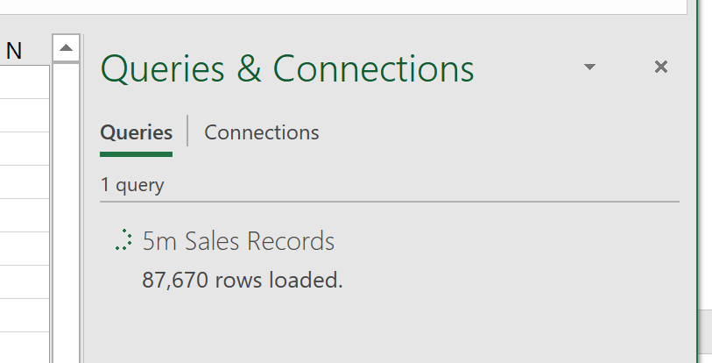



*The process is complete when the status displays 5,000,000 rows loaded.*

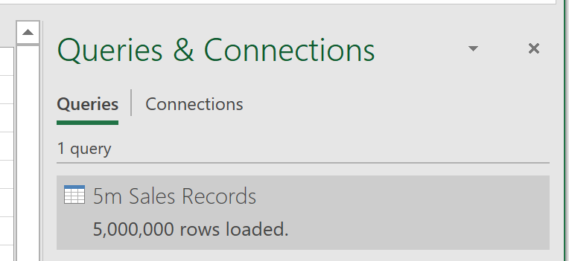



Power Pivot





Manage

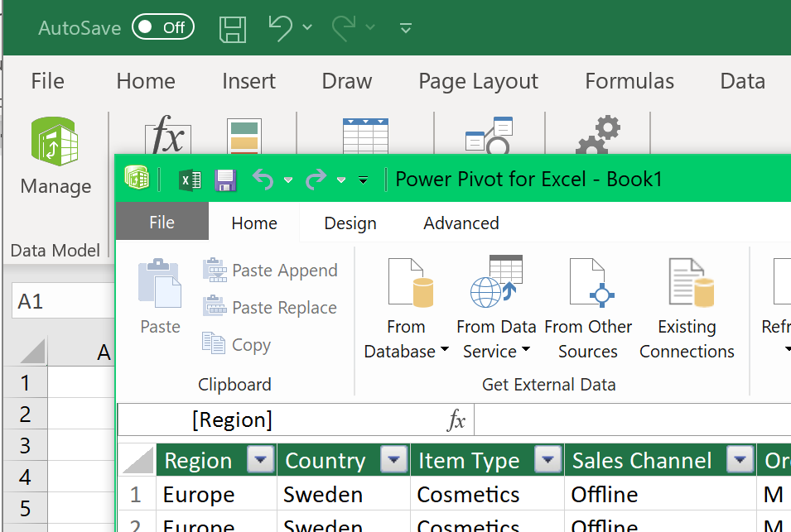



*The Power Pivot window will show up. Scroll all the way down to see five million records!*

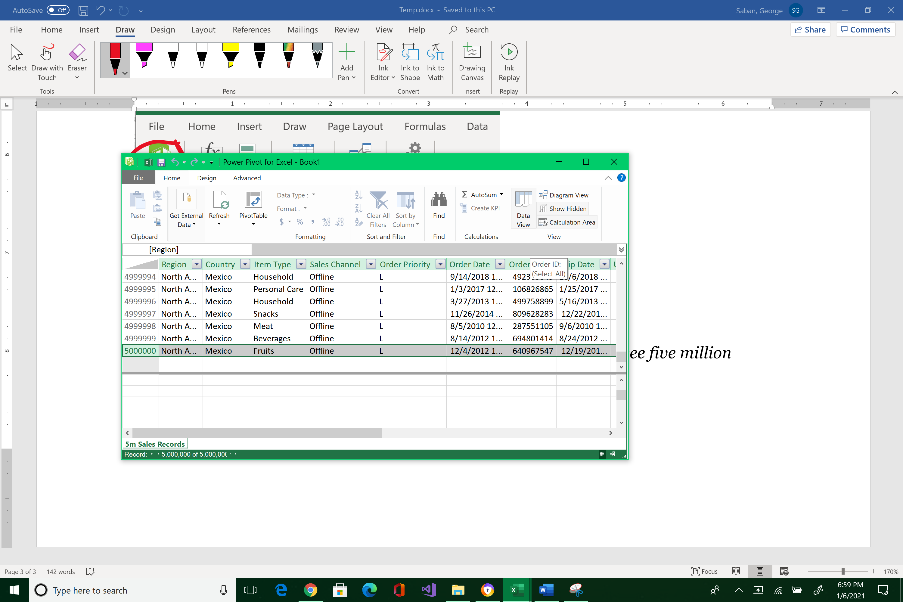



Submit a screenshot to Canvas similar to the image above, showing the five millionth record.